# **Stabilization of the reaction wheel pendulum**

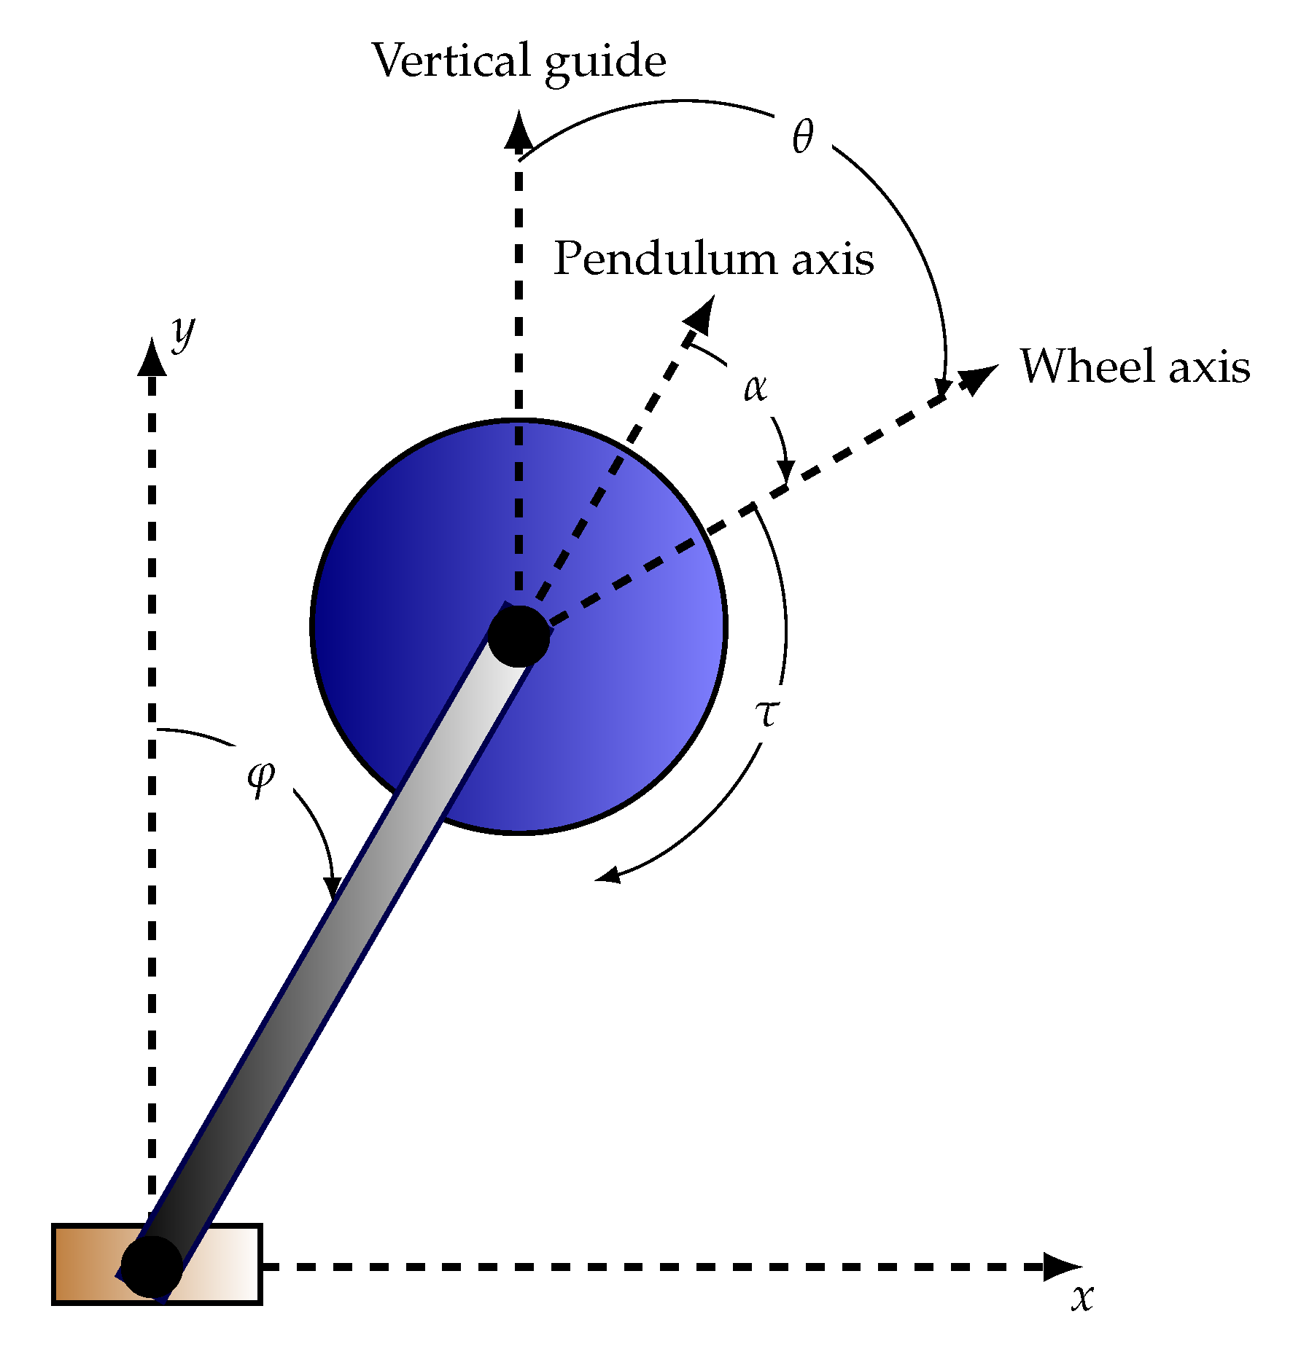

Figure 1. Schematic of reaction wheel pendulum.

The reaction wheel pendulum is a mechanical device precisely controls and stabilizes rotational motion by combining the principles of a reaction wheel and a pendulum. It is made up of a pendulum that is fastened to a motorized reaction wheel that has the ability to produce angular momentum. The system may create torques on the pendulum and hence control its motion by altering the angular momentum of the reaction wheel. This technology has uses in a variety of industries, including as robotics, aeronautical engineering, and spacecraft attitude control. It is useful for tasks like satellite orientation, stabilizing robotic manipulators, and dynamic balancing of mechanical systems due to its capacity to stabilize and control rotational motion. There are two fixed points, corresponding to either the pendulum down (stable) or pendulum up (unstable) configuration zeros. The **goal** is to derive the pendulum to the unstable configuration. To do so you must:

1. Derive the full nonlinear dynamics of the system.
2. Linearize the equations around the unstable fixed point (pendulum up configuration i.e., $θ={90}^{o}$).
3. Either use Laplace domain or the time domain to analyze the system response by analyzing the:
   1. Force free motion (i.e., only excite the system by different initial conditions).
   2. The step/ramp/parabolic response of the system under different initial conditions.
4. Use any of the proposed controllers to derive the pendulum to the unstable configuration:
   1. LQR
   2. MPC
   3. PID along with genetic algorithms to tune the PID gains.

**Project**

1. System Modeling:
   * Develop a mathematical model of the system using first principles.
2. Controller Design:
   * Choose a control strategy from the proposed schemes
   * Design the controller gains based on the system model and desired performance criteria, such as stability and response time.
3. Software implementation:
   * Use MATLAB to simulate the system and to implement the control algorithm in simulation.
4. Documentation and Presentation:
   * Document your work in a report summarizing the project, including the system modelling, controller design, and results analysis.
   * Make a presentation to discuss the project and present the results to the class.